# **Title**

**Learning Chatbot**

# **Problem Statement**

Right now, for students or kids, every parent is facing challenges to find out suitable learning apps which can provide relevant knowledge details or links. Students need to get some information related to various topics and use google or any search engine and get multiple response for their request, and they invest lot of their time and also it leads to confusion to figure out which is the most relevant information.

There are multiple sites, channels, youtube, apps, etc. available to find out their answer and sometimes unnecessary links are visible during search.

Learning chatbot will resolve every parent concern and provide single platform to provide all the learning related information.

# **Invention Description**

Learning Chatbot provides one stop solution for all learning needs. It will provide description, YouTube links for the topic for which information is asked by students based on inputs.

It is one of the most advanced and promising expressions of interaction between humans and machines. However, from a technological point of view, a learning chatbot only represents the natural evolution of a student’s vs machine.

Behind the scenes: How learning chatbot works

There are two different tasks at the core of learning chatbot:

1) User request - This is the first task that learning chatbot performs. It takes the user’s request to identify the user intent and to extract relevant information.

The ability to identify the user’s intent and extract data and relevant information contained in the user’s request is the first condition and the most relevant step at the core of learning chatbot.

2) Returning the response- Once the user’s intent has been identified, the learning chatbot provide the most appropriate response for the user’s request. The answer may be:

• a predefined text

• a contextualized piece of information based on data the user has provided

• a YouTube links for references. For prototypes I have added YouTube links for rhymes section

**High Level Flow Diagram**

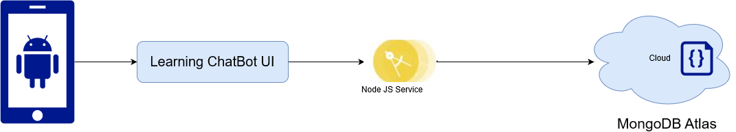

# **Learning Chatbot Snapshots**

**Login Screen Signup Screen**

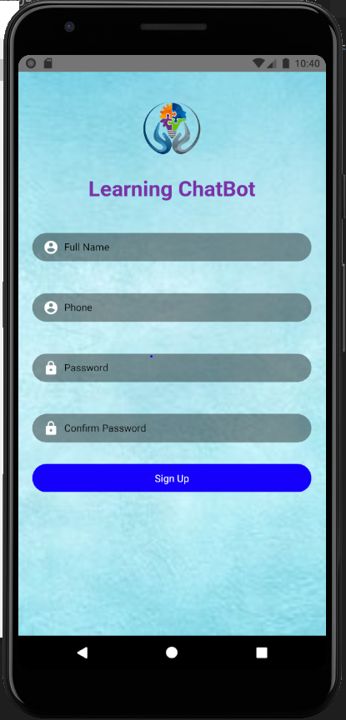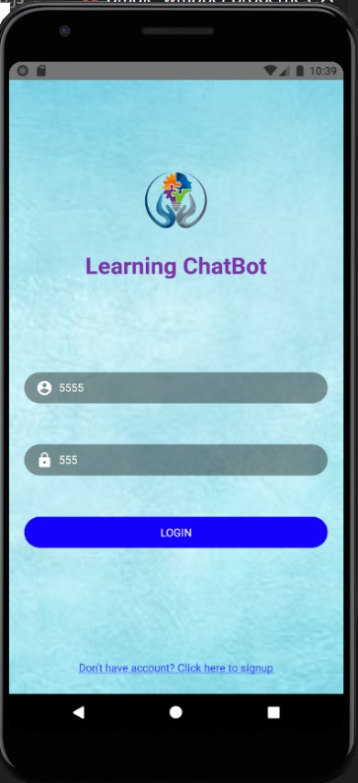

**Subject Selection Screen Category Selection Screen Final Result Screen**

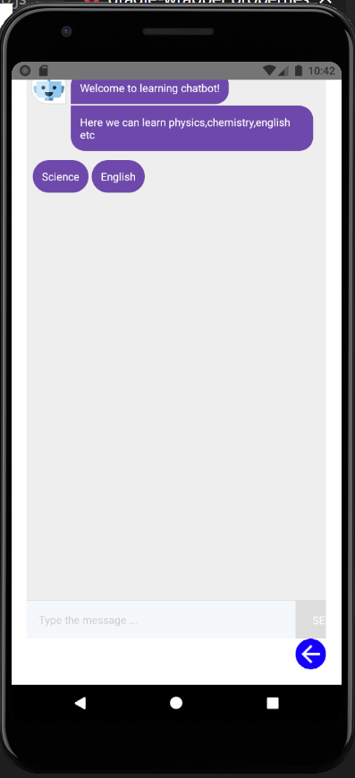 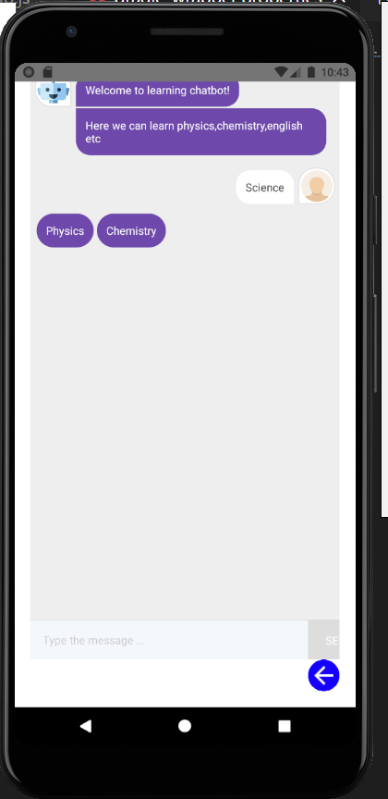 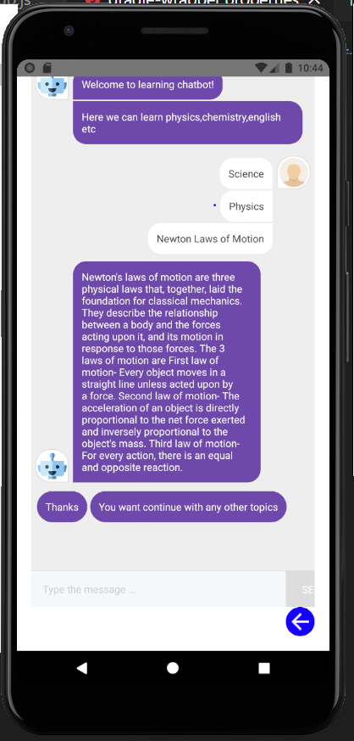

**Future Enhancements**

* Login and sign up validations.
* Integration with backend services (In Progress).
* Save data in database (JSON based-MongoDB Atlas).-Draft version schema is created
* Insert data into database for which I will create admin portal screen.
* Forgot password functionality to be added.
* Age group wise selection.
* Teachers will be able to upload their information, learning tutorial and videos.

**Benefits**

One stop solution for all learning needs.

Provide learning platform for students of all age groups.

Interactive learning.

Secure platform for students.

# **Idea for this research**

I have to do lot of research work on various topics for our projects for marked activity. For this I used google or any search engine and they supplied multiple response for my request. To figure out the relevant information from all the responses received was cumbersome and time consuming and many times also lead to confusion. From this I got an idea to create learning chatbot which can help students provide the exact information they are looking for. It will provide description, YouTube links for the topic for which information is asked by students based on inputs.